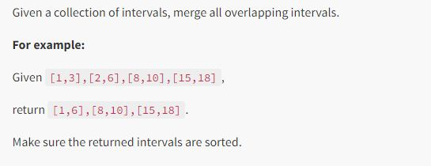

(Question 1)

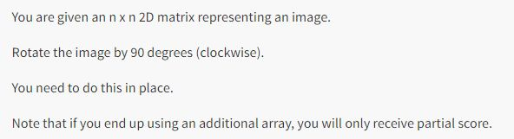

(Question 2) Don’t use any extra space and time complexity should be O(n^2)

Example: I/P: 1 2 3

4 5 6

7 8 9

O/P: 7 4 1

8 5 2

9 6 3

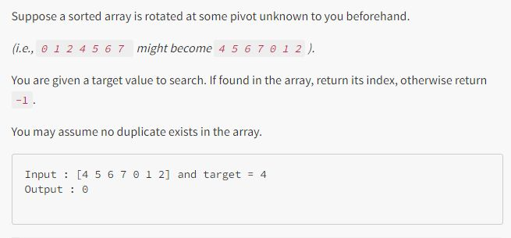

(Question 3) You have to solve in log n time